

German Jordanian University
School of Sustainable Systems Engineering
Electrical and Energy Engineering Department
Electronics I - ECE241

Voltage Regulator (Shunt Regulator)

Students name:
Abdallah Alameddin 20221502043
Saleh Alaeddin 20221
Omar Alamssi 20229502031
Yousef Mustafa 202

Instructor Name: PROF. Gheath Bader

Table of Contents

Zener Diode Overview and its role in voltage regulation 3
I-V characteristics of Zener diode and the significance of the breakdown region. 3
Zener diode applications. 4
Multisim Overview and its importance in circuit design and simulation. 5
Multisim importance: 5
Voltage Regulator Overview 6
State 1: Zener is on 6
State 2: Zener is off 7
State 3: The zener’s “physical failure” 8
Results 10
Conclusion 11
Citations 11

Zener Diode Overview and its role in voltage regulation

Before explaining what a Zener diode is, it’s important we understand what a diode is. A diode is a two-terminal electronic component that conducts current primarily in one direction. Diodes are commonly made from semiconductor material to support its asymmetrical conductance nature. Unlike a regular diode which are intended to block reverse current and can be damaged if the reverse voltage applied exceeds their breakdown rating, a Zener Diode which is a specialized type of PN junction diode can reliably operate in the reverse breakdown region since they are engineered in a manner that allows them to conduct current in the reverse direction once a s specific voltage, known as the Zener Voltage is reached.

The primary role of zener diodes in electronic circuits is voltage regulation. By maintaining a fixed voltage value in between its terminals regardless of current fluctuations, the zener diode can act as a stabilizer. When connected with a load in parallel (shunt configuration), it absorbs excess current from the voltage source to keep the load voltage steady.

I-V characteristics of Zener diode and the significance of the breakdown region.
The zener diode goes through several different regions or stages, of which are explained below.
The right half side of the characteristics curve is the part in which the zener diode receives forward voltage, which is positive voltage across its anode to cathode terminals. The diode in this region is forward biased. During this period, the current is small for a while until it spikes exponentially up once the voltage reaches a certain point, called the threshold voltage.
The left half side of the characteristics curve is the more important part, when considering zener diodes. This is the part in which the zener diode receives positive voltage across its cathode to anode terminals. The diode in this region is reverse biased. At first, when receiving reverse voltage, the current is very small. There is only a small current, called the leakage current, flowing through the diode. Once it hits the breakdown voltage, the current drastically increases. This current is called the avalanche current, because it spikes so drastically. The breakdown voltage point is also important, not just because of the avalanche current, but more importantly because once the voltage of the zener diode has reached this point, it remains constant at this voltage, even though the current across it may increase largely. This makes the zener diode useful in applications such as voltage regulation.
The zener diode has an important characteristic in that once the voltage across a zener has reached this breakdown voltage, also called a zener diode's zener voltage, VZ, the voltage that a zener drops across itself will not continue to increase. For example, if a zener diode has a zener voltage of 5.1V, and the voltage feeding the diode is approximately 5.1V, the zener will drop the 5.1V across its terminals. Now if the voltage supplying it acontinues to increase, to say 12V, the zener diode will maintain its zener voltage, 5.1V, even though the voltage (and current) supplying it continues to increase.
This is the single most important characteristic of a zener diode, which as stated before, allows it to act as a voltage regulator in a circuit. The voltage that is dropped across a zener will not exceed its breakdown or zener voltage, even if the voltage or current in the circuit increases, which is what the I-V characteristics curve above depicts.

Zener diode applications.

- Voltage Regulation; most common use, where the diode has a fixed output voltage and is providing it to a load despite fluctuations or changes in voltage or load resistance.
- Over-Voltage Protection; zener diode acts as a safety valve in crowbar or clamping circuits. If a spike exceeds the zener rating, the excess energy is conducted to the ground hence protecting sensitive components from damage.
- Waveform Clipping; clip or limit the amplitude of AC signals (e.g., converting a sine wave to a square wave).
- Reference Voltage; due to its precise breakdown voltage, they serve as stable reference points for analog to digital converters.

LTSpice Overview and its importance in circuit design and simulation.
LTspice is a high-performance SPICE-based circuit simulation software developed by Analog Devices. It is widely used by electronics engineers, researchers, and students for designing, simulating, and verifying analog and mixed-signal circuits before physical implementation. LTspice is freely available and is known for its speed, accuracy, and extensive built-in component library.
Multisim is widely used in academia and industry for circuits education, electronic schematic design and SPICE simulation.

Importance in Circuit Design:
LTspice plays a critical role in the modern circuit design workflow for several reasons. First, it allows engineers to verify circuit behavior theoretically before committing to physical prototyping, saving both time and cost. Second, it helps identify potential issues such as overcurrent conditions, instability, or incorrect component selection early in the design process. Third, it provides visual confirmation of theoretical calculations, as demonstrated in this project where the simulated results closely matched the mathematically derived values.

Voltage Regulator Overview

The simulations
For the simulations we wanted to show the state the zener diode is in on different conditions. The main parameter that will be changing in different testing procedures will be the value of R load.
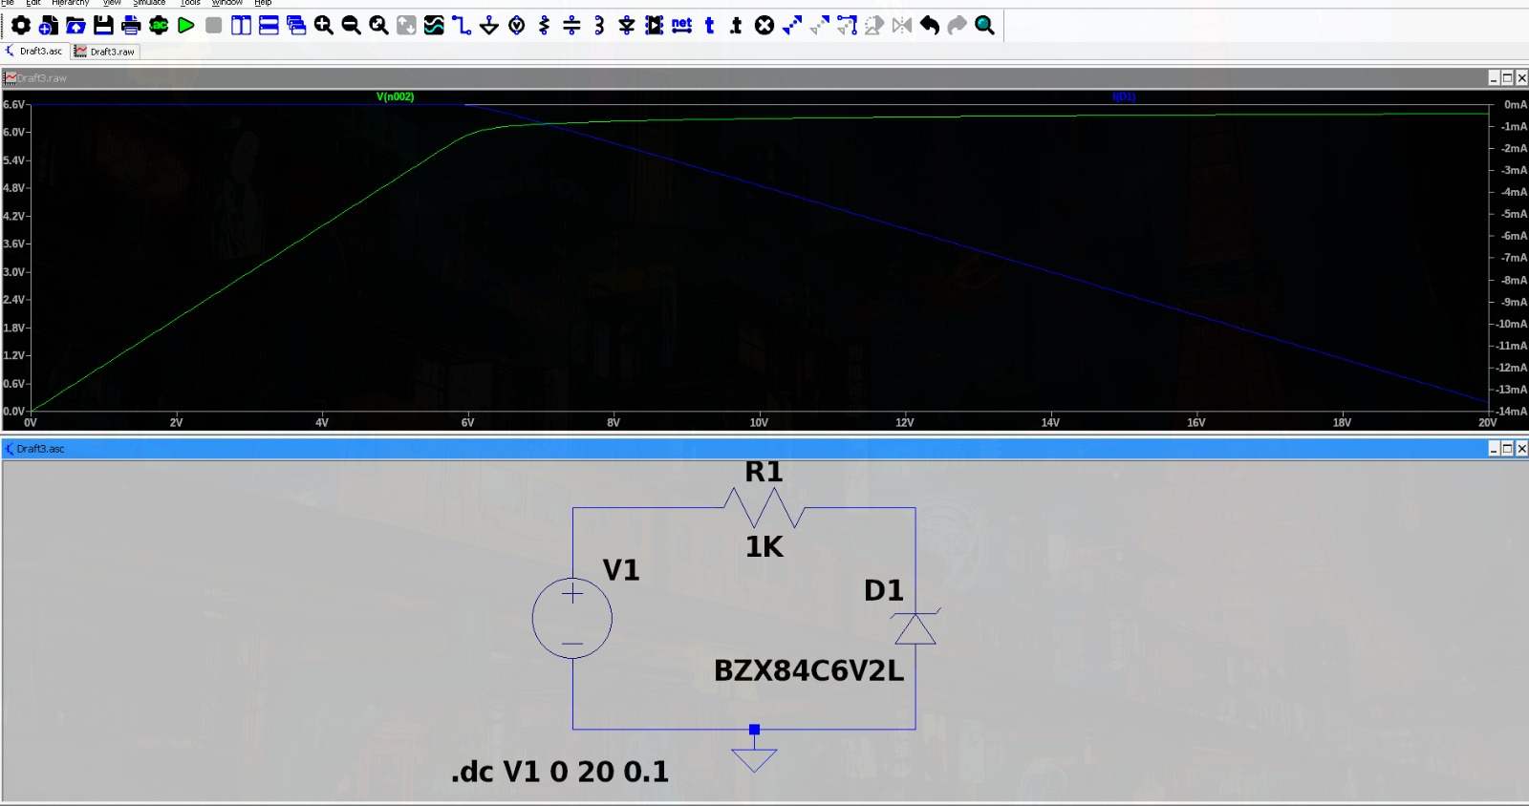

State 1: Zener is on
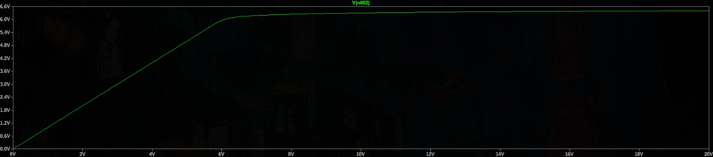
In this state, the load resistance is set to 10kΩ, which draws only a small load current. This allows the output voltage to reach and maintain the Zener breakdown voltage of 6.2V, keeping the diode fully operational in its regulation region.
Using Vin=10
VRs= Vin-Vz= 10 – 6.2=3.8V
Is= 3.8/1000= 3.8mA
IL= 6.2/10000= 0.62mA
Iz=Is-IL = 3.8mA – 0.62mA = 3.18mA
Pz=Iz × Vz = 3.18mA × 6.2V = 19.72 mW (well within 300 mW rating)
The simulation confirms that the output voltage is regulated and stable at approximately 6.2V across the Zener diode.

State 2: Zener is off
In this state, the load resistance is reduced to 1 kΩ, which falls below the minimum threshold of approximately 1.63 kΩ required to maintain regulation. With Rs = 1 kΩ and Vin = 10 V, the maximum available source current Is = 3.8 mA. A load of 1 kΩ would require IL = 6.2 mA to stay regulated, which exceeds Is, so the Zener turns off and Vout drops to ≈50 % of Vin ≈ 5 V.
An output of ≈5 V on a Zener rated at 6.2 V means the diode never enters the breakdown region, defeating the purpose of voltage regulation.

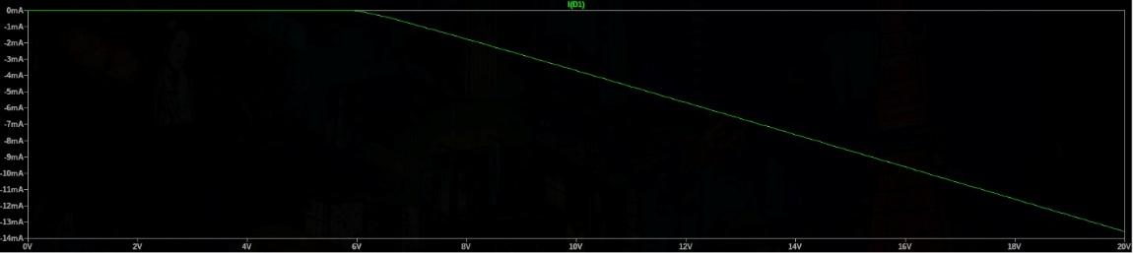

State 3: The zener’s “physical failure”

In this state, we simulate a condition where the Zener diode would fail in a real circuit. The load is treated as an open circuit, meaning all current from the source must pass entirely through the Zener diode. The input voltage is also raised to 50V to exceed the diode's power rating.
Iz = (50-6.2)/1000 = 43.8 mA
Pz = 6.2V * 43.8 mA = 0.271W
In a real circuit, a power dissipation of 271.6 mW through the diode would cause physical failure — the diode would overheat and potentially burn or produce smoke. However, since LTspice is purely a mathematical simulation, it does not model thermal damage and will continue to display an output of approximately 6.2V, which would be incorrect in reality.
This state highlights the critical importance of proper component selection and operating within rated limits during circuit design.
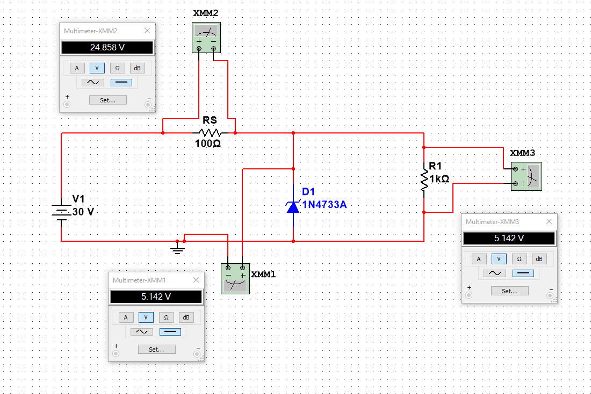

Characteristic table:
Parameter | Symbol | Value | Unit
Nominal Zener Voltage | Vz | 6.2 | V
Test Current | Izt | 5 | mA
Maximum Zener Current | Izm | 48 | mA
Maximum Power Dissipation | P | 300 | mW
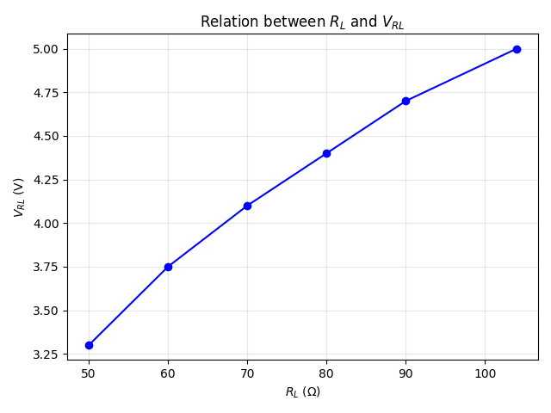

Results
The Zener voltage regulator was tested with different load resistances using a variable load resistor. The input voltage was set to 10 V, the series resistor Rs = 1 kΩ, and the BZX84C6V2L Zener diode (Vz = 6.2 V, Pz_max = 300 mW) was used. A DC sweep from 0 V to 20 V was also performed in LTSpice to determine the input voltage range for breakdown-region operation: Vmin = 7.2 V and Vmax = 20 V (source-limited).
When in regulation, the voltage across the Zener diode was constant at 6.2 V for all valid load conditions. The current through the series resistor Is = (Vin−Vz)/Rs = (10−6.2)/1000 = 3.8 mA. Zener current Iz varied with load but remained positive, confirming regulation. Maximum Zener power dissipation at Vmax = 20 V: Iz = 13.8 mA, Pz = 85.6 mW (28.5 % of 300 mW rating).
$$I_{S}=\frac{V_{i}-V_{z}}{R_{s}}=\frac{10-6.2}{100}=3.8 mA$$
For maximum load resistance (RL = 10 kΩ, Vin = 10 V, Rs = 1 kΩ):
Is = (10 – 6.2) / 1000 = 3.8 mA
IL = 6.2 / 10000 = 0.62 mA
Iz = 3.8 – 0.62 = 3.18 mA → Zener ON, Vout = 6.2 V$\left(R_{L} = 1 kΩ\right)$
$$I_{L}=\frac{V_{z}}{R_{L}}=\frac{6.2}{1000}=6.2 mA \\ I_{Z}=I_{S}-I_{L}=43.9 mA$$
For minimum load resistance (RL = 1 kΩ — below regulation threshold):
IL needed = 6.2 / 1000 = 6.2 mA > Is = 3.8 mA → Zener OFF
Vout = Vin × RL / (Rs + RL) = 10 × 1000 / 2000 ≈ 5.0 V
RL_min for regulation = Vz / Is = 6.2 / 0.0038 ≈ 1.63 kΩ$I_{Z}≈0$
$$R_{L(min)}=\frac{V_{z}}{I_{S}}=\frac{5.1}{0.049}≈104 Ω$$
Load Resistance (Ω) | Output Voltage (V) | Load Current (mA) | Zener Current (mA)
10000 (10 kΩ) | 6.2 | 0.62 | 3.18
3000 (3 kΩ) | 6.2 | 2.07 | 1.73
1000 (1 kΩ) | ≈ 5.0 (unregulated) | 5.00 | 0 (Zener off)

Conclusion
In this experiment, the voltage regulator of a Zener diode with a 1N4733A (5.1 V) Zener diode was modeled, and the simulations were done using Multisim and mathematical theories. It was confirmed that the Zener diode functions to regulate the voltage at 5.1 V if it is operating in the breakdown region.
Our calculations made it possible to determine the required values of current, power dissipation, and load resistance for the circuit to work properly. These calculations were confirmed by the results of the simulation done by the Multisim program, which was very accurate; that is, the diode was able to regulate the voltage only if the value of the load resistance was higher than the minimum value calculated. One of the most important things that were learned from working on this project was that simulation packages are limited. For instance, when the maximum power value was exceeded, the simulation program yielded a result showing the regulated output; however, if that were the case, the components would burn out.

Citations
[1] Diode, https://en.wikipedia.org/wiki/Diode
[2] Zener diode, https://en.wikipedia.org/wiki/Zener_diode
[3] Electronic Components Datasheet, https://www.alldatasheet.com/datasheet-pdf/pdf/15031/PHILIPS/1N4733A.html
[4] Zener Diode I-V Characteristics Curve, https://www.learningaboutelectronics.com/Articles/Zener-diode-IV-characteristics-curve
[5] NI Multisim, https://www.geeksforgeeks.org/electronics-engineering/what-is-multisim/
[6] Zener Diode I-V Characteristic Analysis, https://www.scribd.com/document/665139590/CHARACTERISTICS-OF-ZENER-DIODE
[7] Zener diode as a voltage regulator, https://www.hansrajcollege.ac.in/hCPanel/uploads/elearning/elearning_document/lect_35_and_36.pdf

